Lab 1:
- Q1: Name the four stages a C source file passes through on its way to an executable, and what each stage takes as input and produces as output.
The four stages are preprocessing, compilation, assembly, and linking. Preprocessing handles directives such as #include and #define. Compilation converts the processed C code into assembly code. Assembly creates object files (.o), and linking combines the object files and libraries to create the final executable.
- Q2: What does -Wall add to a gcc invocation? What does -Wextra add beyond -Wall? What does -Werror change about how warnings are treated?
-Wall enables many common compiler warnings. -Wextra enables additional warnings that are not included with -Wall. -Werror treats warnings as errors, so the program will not compile successfully until those warnings are fixed.
- Q3: What is the difference between compiling a file with gcc -c versus without -c?
Using gcc -c compiles the source file and creates an object file (.o) without linking it. Without -c, GCC also performs the linking step and creates the final executable.
- Q4: In a Makefile rule, what are the target, the prerequisites, and the recipe?
The target is the file that make needs to create. The prerequisites are the files that the target depends on. The recipe is the command that make executes to build the target.
- Q5: Why does make usually avoid rebuilding a target that is already up to date, and how does it decide?
make checks the modification times of the target and its prerequisites. If the target already exists and is newer than its prerequisites, make considers it up to date and does not rebuild it. If a prerequisite is newer, it rebuilds the target.
- Q6: What is the difference between a local git commit and pushing that commit — why can a commit exist and still not count as submitted work for this course?
A git commit saves changes to the history of the local repository on the Raspberry Pi. A git push sends those committed changes to the remote repository, such as GitHub. A commit that has not been pushed is still only on the local machine, so the instructor cannot see it in the remote repository.
- Open a terminal on your Pi and record the output of `gcc --version`, `make --version`, and `git --version`.
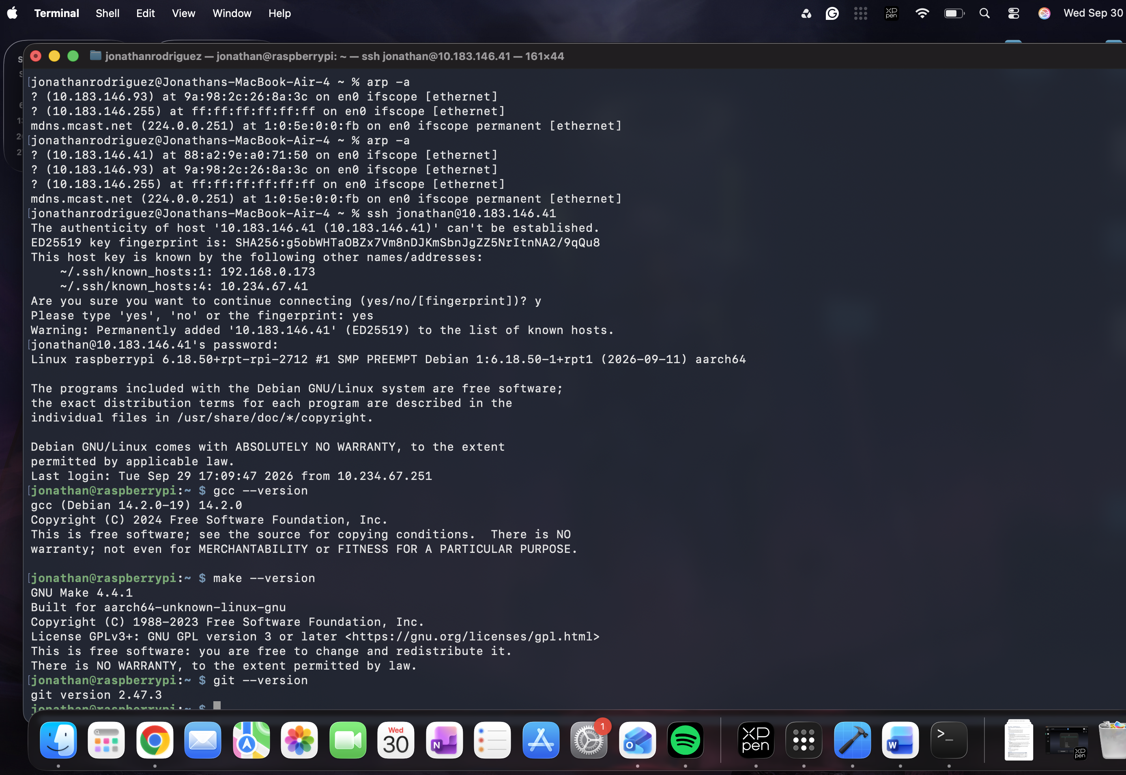
- Run `git config --global user.name` and `git config --global user.email`; if either is unset, configure them.
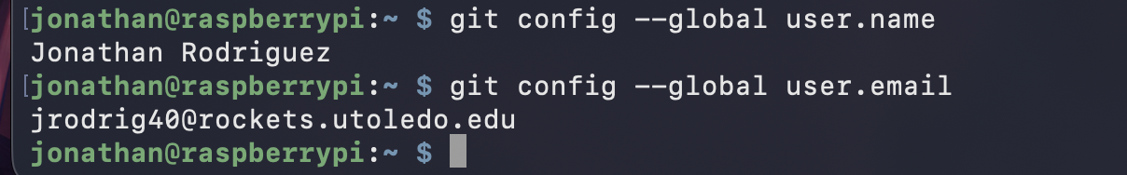
- Confirm you can reach your assigned git repository (clone it if you have not already, or run `git remote -v` and `git fetch` if you have) and record the outcome.
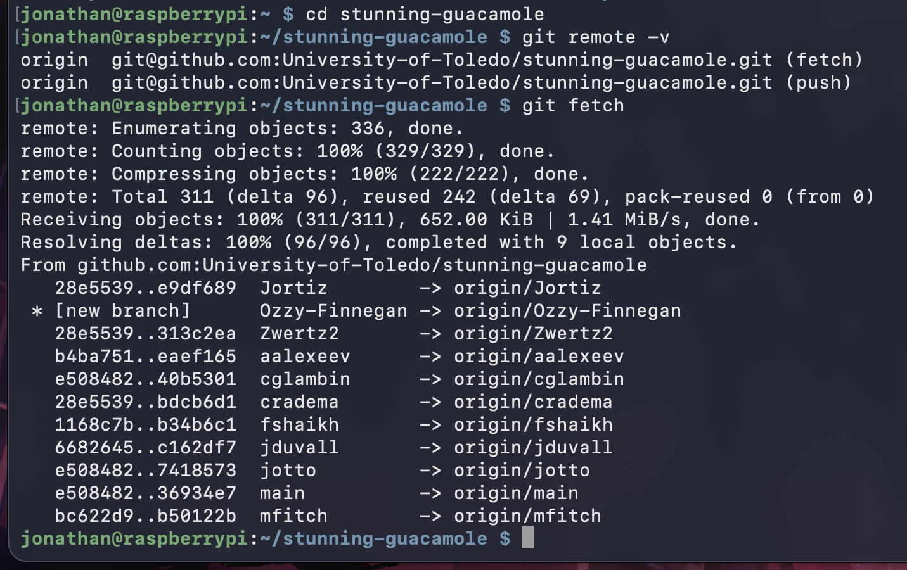
- Your own-words explanation of compiler errors versus linker errors.
A compiler error happens when there is a problem in the source code that prevents it from compiling. A linker error happens after the code is compiled, when the linker cannot find a function or other reference needed to create the final executable.

